#### 

#### *Issue : section 3.3.1 Not all users will have Artifactory in their Okta to start with - we should probably tell them what Access@WOrk request to submit first or how to request access to get Artifactory added to their Okta ….you need to add Access@WOrk for new users and those who does not have Okta yet*

#### *Cloud Based Jfrog Artifactory Integration Via Okta*

#### **Login to BOKF Cloud Environment via Okta**

**Access JFrog Artifactory via Okta:**

* Navigate to the Okta dashboard.
* Log in to Okta using your BOKF credentials.
* Once logged in, locate the JFrog Artifactory application in the Okta menu or dashboard.
* Click on the JFrog Artifactory application to be redirected to the BOKF cloud-based Artifactory instance. This will automatically log you in using **Single Sign-On (SSO).**

#### **Access for New Users and Users Without Okta**

* **New users or those who do not have Artifactory access in Okta** need to request access via **Access@Work** before they can use the JFrog Artifactory application.
* Ensure that users submit the appropriate **Access@Work request** to have **Artifactory added to their Okta dashboard.**
* If a user does not have an Okta account yet, they must first request Okta access before proceeding with Artifactory access.

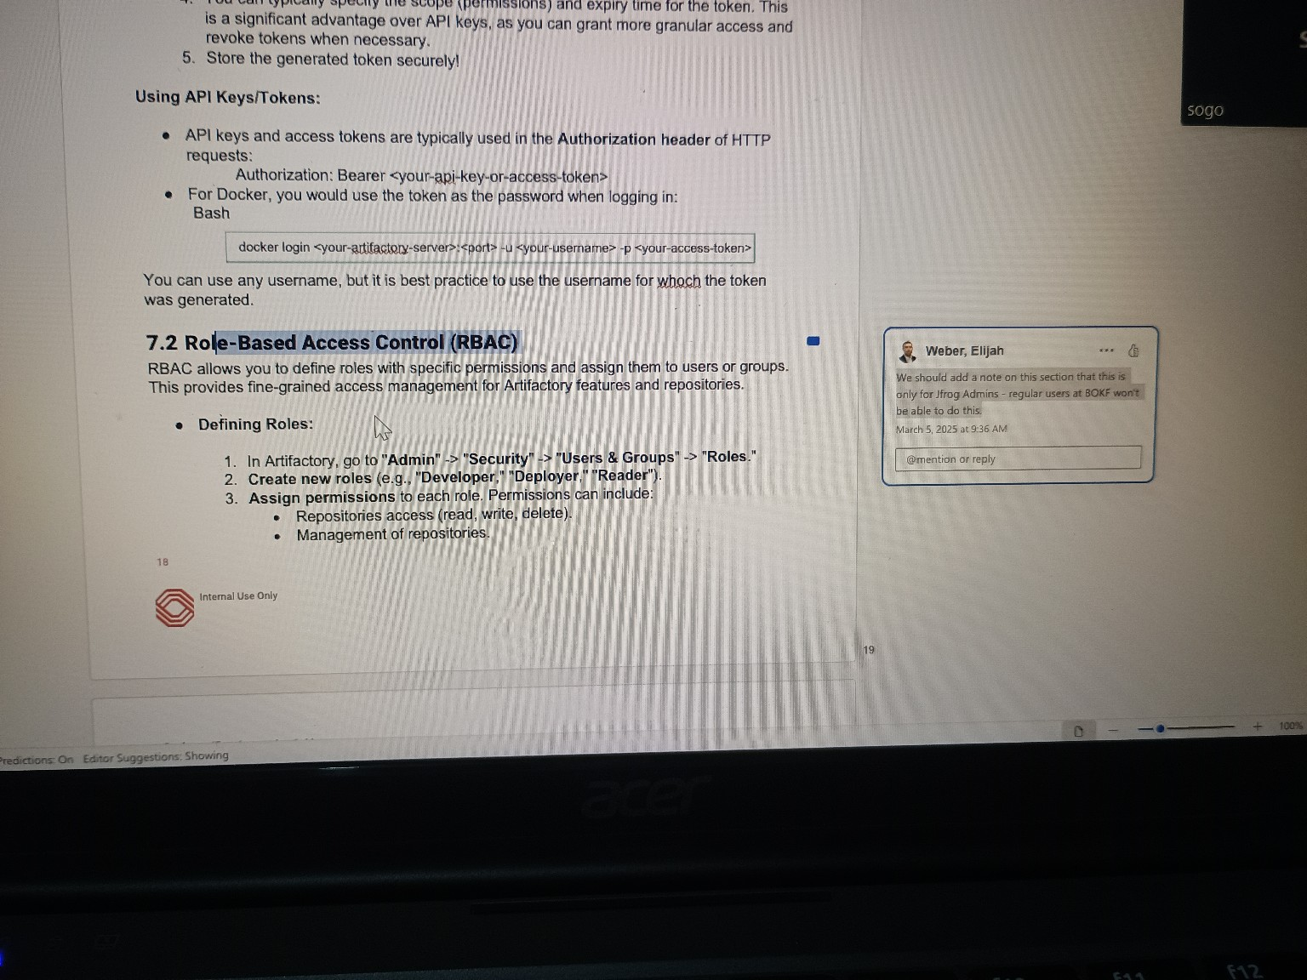

Issue : For section 7.2 RBAC: We should add a note on this section that this is only for Jfrog Admins - regular users at Bokf won't be able to do this….we need a section for how normal users can access it, not only RBAC

**Role-Based Access Control (RBAC) - Admin Access**

RBAC allows you to define roles with specific permissions and assign them to users or groups. This provides fine-grained access management for Artifactory features and repositories.

##### **Defining Roles (For JFrog Admins Only)**

**Note:** The following actions can only be performed by **JFrog Admins**. Regular users at BOKF will not have these permissions.

1. In Artifactory, go to **Admin → Security → Users & Groups → Roles.**
2. **Create new roles** (e.g., "Developer," "Deployer," "Reader").
3. **Assign permissions** to each role. Permissions can include:
   * Repositories access (read, write, delete).
   * Management of repositories.

### **Access for Regular Users at BOKF**

Regular users who need access to Artifactory should follow these steps:

1. **Request Access via Access@Work:**
   * Users who do not have Artifactory access should submit a request through **Access@Work**.
   * Specify the required level of access (e.g., Read-Only, Developer, or Deployer).
2. **Accessing Artifactory:**
   * Once access is granted, users can log in to Artifactory via **Okta SSO**.
   * Navigate to the Artifactory dashboard to view repositories.
3. **Permissions for Regular Users:**
   * Regular users will have **read-only** access by default.
   * Additional permissions (write, deploy) must be requested separately through the IT support team or JFrog Admins.